SQL ASSIGNMENT 2

1. Display the details from Customer table who is from country Germany.

select * from Customer

where Country='Germany'

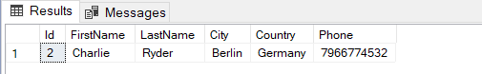

2. Display the full name of the customer.



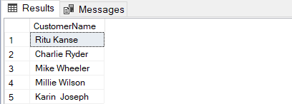

3. Display the customer details whose name holds second letter as i.

select * from Customer

where FirstName LIKE '_I%'

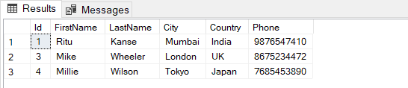

4. Select order Details where unit price is greater than 50 and less than 80.

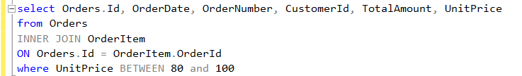 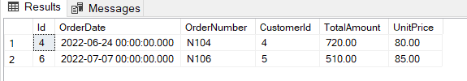

5. Display order details which contains shipping date and arrange the order by date.

select * from Orders

where ShippingDate is not NULL

order by ShippingDate

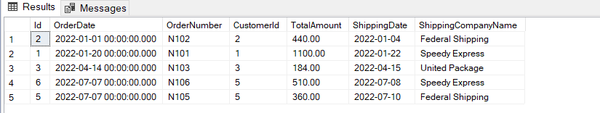

6. Print the orders shipped by ship name ‘Speedy Express’ between 2 dates (Choose dates of your choice)

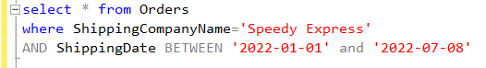 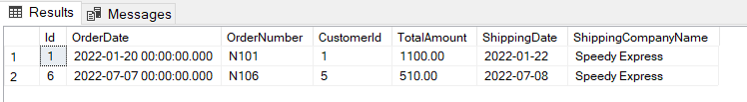

7. Print the products supplied by 'Exotic Liquids'.

select * from Product

where SupplierName='Exotic Liquids'

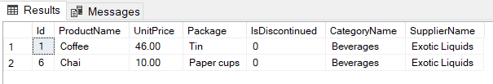

8. Print the average quantity ordered for every product.

select * from OrderItem

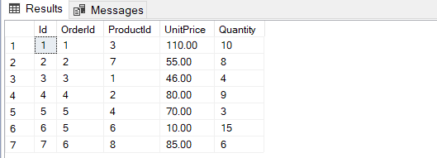

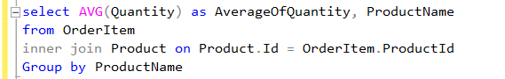 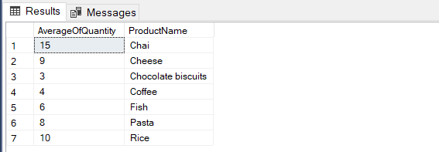

9. Print all the Shipping company name and the ship names if they are operational.

select * from Orders

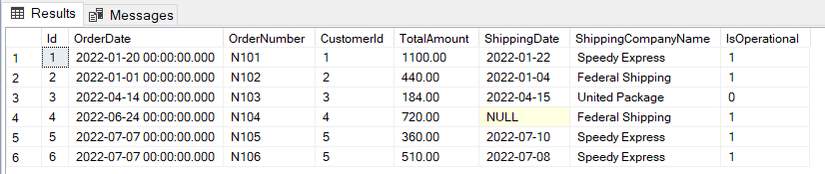

 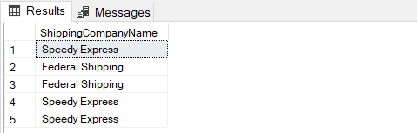

10. Print all Employees with Manager Name.

select EmployeeName, ManagerName

from Employee

where ManagerName IS NOT NULL

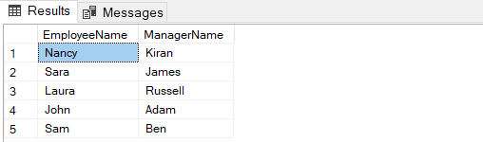

11. Print the bill for a given order id. Bill should contain ProductName, CategoryName, price after discount.

**Create table Bill**

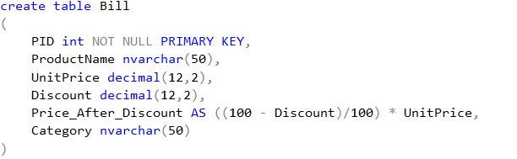

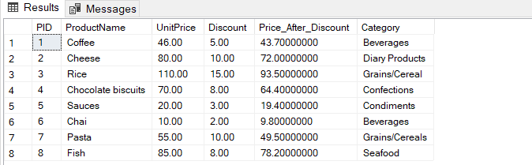

**Query**

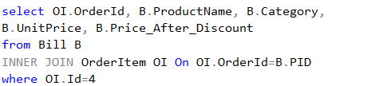

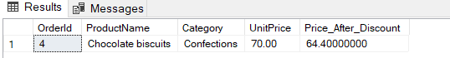

12. Print the Total price of orders which have the products supplied by 'Exotic Liquids' if the price is > 50 and also print it by Shipping company's Name.

